**Digital Marketing Assignment**

**Term-1**

# Module -4

• What are the main factors that can affect PPC bidding?

Ans: The main factors are Keywords, Quality score, Budget, Competition for keywords, Audience, Landing Page.

• How does a search engine calculate actual CPC?

Ans: It is calculated by dividing the cost by the number of clicks on ad.

• What is a quality score and why it is important for Ads?

Ans: Quality Score is a diagnostic tool meant to give you a sense of how well your ad quality compares to another advertiser. It is useful to improve ads, landing pages and Keyword selection.

• Create an ad for your website/ blog in Google Ads that display on the display network with the properly targeted audience

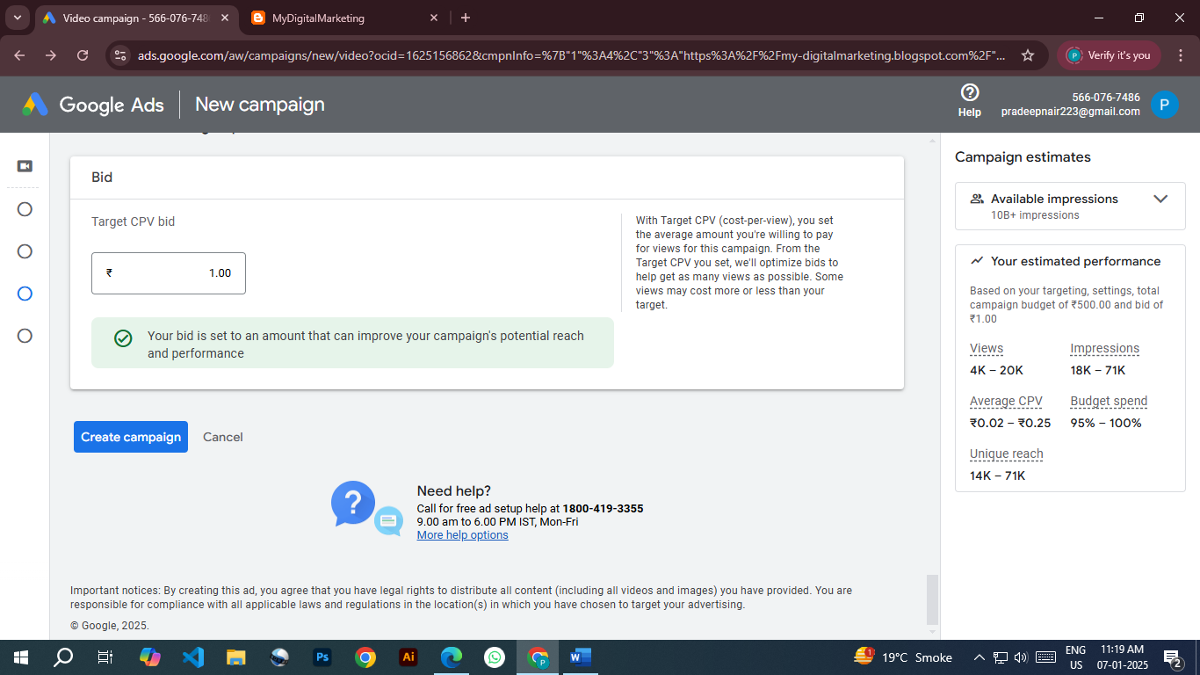

• Create an ad forwww.tops-int.com to get the maximum Clicks.

• Create an ad for [www.tops-int.com](http://www.tops-int.com)

o Create an ad for the display network.

o Choose a proper Target audience.

o Expected conversion: need maximum user engagement within the budget.

o Budget: 5000.

<https://ads.google.com/aw/campaigns/new/express?campaignId=22105146391&ocid=1665560331&subid=in-en-awhp-g-aw-c-t-kwp-hero%21o2&step=crev&mode=signup&euid=1084757464&__u=3753606936&uscid=1665560331&__c=6983676019&authuser=0&sourceid=emp>